PRAKTIKUM BASIS DATA

MODUL 5
Scripting Agregate Function


Oleh:

Fatikhah Sukma Arti 103122400019

PROGRAM STUDI S1 REKAYASA PERANGKAT LUNAK
DIREKTORAT KAMPUS PURWOKERTO
UNIVERSITAS TELKOM
2026
JURNAL

- Tampilkan nomor teater beserta judul film nya yang memiliki pendapatan total lebih dari 150000 !
SELECT
J.ID_THEATER AS NOMOR_TEATER,
F.JUDUL AS JUDUL_FILM,
SUM(TH.HARGA) AS TOTAL_PENDAPATAN
FROM TRANSAKSI T
JOIN JADWAL J ON T.ID_JADWAL = J.ID_JADWAL
JOIN FILM F ON J.ID_FILM = F.ID_FILM
JOIN THEATER TH ON J.ID_THEATER = TH.ID_THEATER
GROUP BY J.ID_THEATER, F.JUDUL
HAVING SUM(TH.HARGA) > 150000;

Screenshots :
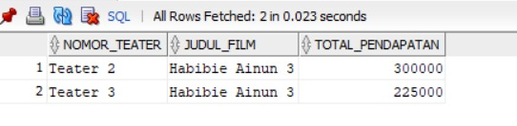
- Tampilkan film yang paling banyak ditonton dan status = pesan !
SELECT
F.JUDUL AS JUDUL_FILM,
COUNT(T.KODE_PEMESANAN) AS TOTAL_TIKET_TERJUAL
FROM TRANSAKSI T
JOIN JADWAL J ON T.ID_JADWAL = J.ID_JADWAL
JOIN FILM F ON J.ID_FILM = F.ID_FILM
WHERE T.STATUS = 'pesan'
GROUP BY F.JUDUL
HAVING COUNT(T.KODE_PEMESANAN) = (
SELECT MAX(COUNT(TR.KODE_PEMESANAN))
FROM TRANSAKSI TR
WHERE TR.STATUS = 'pesan'
GROUP BY TR.ID_JADWAL
);

Screenshots :
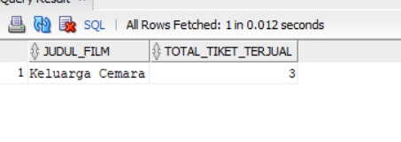
- Tampilkan nomor teater dan rata rata pendapatannya !
SELECT
J.ID_THEATER AS NOMOR_TEATER,
AVG(TH.HARGA) AS "AVG(HARGA)"
FROM TRANSAKSI T
JOIN JADWAL J ON T.ID_JADWAL = J.ID_JADWAL
JOIN THEATER TH ON J.ID_THEATER = TH.ID_THEATER
GROUP BY J.ID_THEATER;

Screenshots :
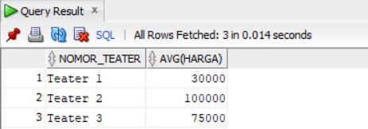

- Tampilkan judul, nomor teater, dan jumlah film yang diputar. Dimana film yang berjudul film ‘Habibie Ainun 3’ !
SELECT
J.ID_THEATER AS NOMOR_TEATER,
AVG(TH.HARGA) AS "AVG(HARGA)"
FROM TRANSAKSI T
JOIN JADWAL J ON T.ID_JADWAL = J.ID_JADWAL
JOIN THEATER TH ON J.ID_THEATER = TH.ID_THEATER
GROUP BY J.ID_THEATER;

Screenshots :
